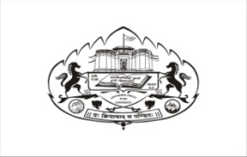
SAVITRIBAI PHULE PUNE UNIVERSITY
DEPARTMENT OF EDUCATION AND EXTENSION

LIST OF STUDENTS QUALIFYING IN STATE/ NATIONAL/ INTERNATIONAL LEVEL EXAMINATIONS
(2021- 2022)

Sr. No. | Roll No. | Name of the Student | Name of the Examination / Level of the Examination | Category
1 | MR22009127 | Rekha Jadhawar | NET Exam (National Level) | NT

